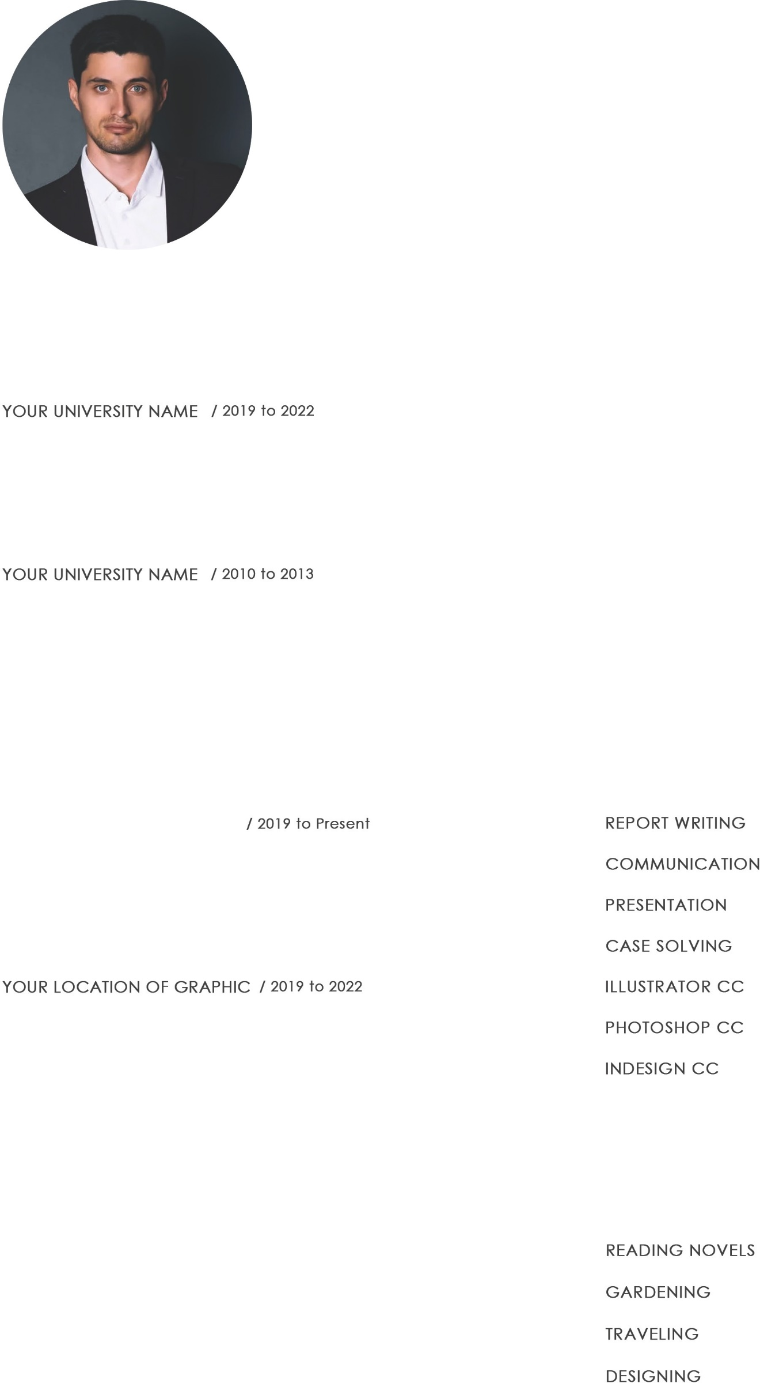
NOAH SMITH
GRAPHICS DESIGNER

Resume
Friday, 02/02/2022

123 Lorem ipsum, st 00, location, WT
+0-123-456-456 | info@yourdomain.com | www.yourdomain.com

Post Graduate in Graphic Design
Lorem Ipsum is simply dummy text of the printing and typesetting indus- try been the industry's standard dummy text ever since the 1500s, when an printer took a galley of type and it to make a type book.

Graduate in Graphic Design
Lorem Ipsum is simply dummy text of the printing and typesetting indus- try been the industry's standard dummy text ever since the 1500s, when an printer took a galley of type and it to make a type book.
Hii ! I’M Noah Smith Lorem Ipsum is simply dummy text of the printing and typesetting industry been the in- dustry's standard dummy text ever since the 1500s, when an printer took a galley of type and it to make a type specimen book.
Lorem Ipsum is simply dummy text of the printing and typesetting industry been the industry's standard took a galley of type and it to make a type specimen book.
Lorem Ipsum is simply dummy text of the printing ever since the 1500s, when an printer took a galley of type and it to make a type specimen book.

ART & DESIGN CORPORATION
Resume & Logo Graphics Artist
Lorem Ipsum is simply dummy text of the printing and typesetting indus- try been the industry's standard dummy text ever since the 1500s, when an printer took a galley of type and it to make a type book.

Online Graphic Developer
Lorem Ipsum is simply dummy text of the printing and typesetting indus- try been the industry's standard dummy text ever since the 1500s, when an printer took a galley of type and it to make a type book.
REFERENCE INTERESTS

MR. NOAH SMITH / Web and UI Developer

Lorem Media of Creative Design
Address: Street - 123, Lorem ipsum, street 00, location, WT
Telephone: +0 123 456 456 0
E-mail: info@yourdomain.com

