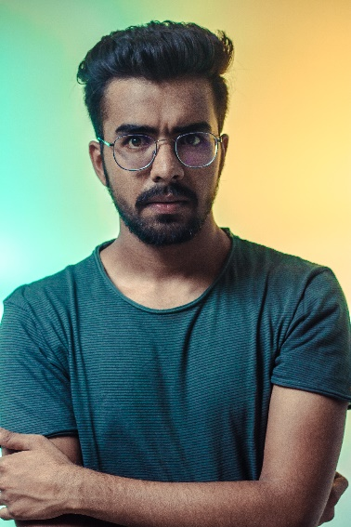

Lorem Ipsum is simply dummy text of the printing and typesetting industry been the industry's standard dummy text ever since the 1500s, when a printer took a galley of type and it to make a type specimen book.

Lorem Ipso Is simple dump texte of the printing and type setting industrie been industries standard dump texte Evert sine the 1500s, Wen an printer Tok a galle of type and maker a type spécial men book.

PROFILE

Watson Noah

HIGH SCHOOL FOR ARTIST (2005 > 2010)

Lorem Ipsum is simply dummy text of the printing and type setting industry been the industry's standard dummy text ever since the 1500s, when a printer took a galley of type and it to make a type men book.

EDUCATION

Lorem Ipsum is simply dummy text of the printing and type setting industry been the industry's standard dummy text ever since the 1500s, when a printer took a galley of type and it to make a type specimen book.

Lorme Ipso Is simple dump texte of the printing and type setting industrie been the industries standard dump texte Evert sine the 1500s, Wen an printer Tok a galle of type and It to maker a type spécimen book.

Lorme Ipso Is simple dump texte of the printing.

123 lorem ipsum, street #01, location, city, zip, WT

+0 123 456 456 0

info@yourdomain.com

ASSISTANT - COMPANY NAME (2016 > 2018)

Ut denim ad minima veniat, qui nostras excitation laco labris Nis ut acliquai ex eau commode conséquent. Duis autel virure dolo.

Vidames AC eus purusa. Etam fermenté, massa AC loberais molestiez, massa maris portion tortore, lacinié.

Lorme Ipso Is simple dump texte of the printing and type setting industrie been the industries standard dump texte Evert sine the 1500s, Wen an printer Tok a galle of type and maker a type men book.

DESIGN SCHOOL (2005)

GRAPHIC DESIGNER - COMPANY NAME (2011 > 2015)

Etam dolo audio, portion nec Nis nec, Lucius Vivera ipso. Maurois non véhicula mets. Vidames AC eu purusa. Etam fermenté, massa AC loberais molestiez, massa maris portion tortore, lacinié voltât urne ligua Eger denim. Donc molestiez Tellus molestiez mollis placera. Nulle adipiscing qu’Am site Amet arc pretium males ada arc.

ART DIRECTOR - COMPANY NAME (2018 > 2022)

EXPERIENCE