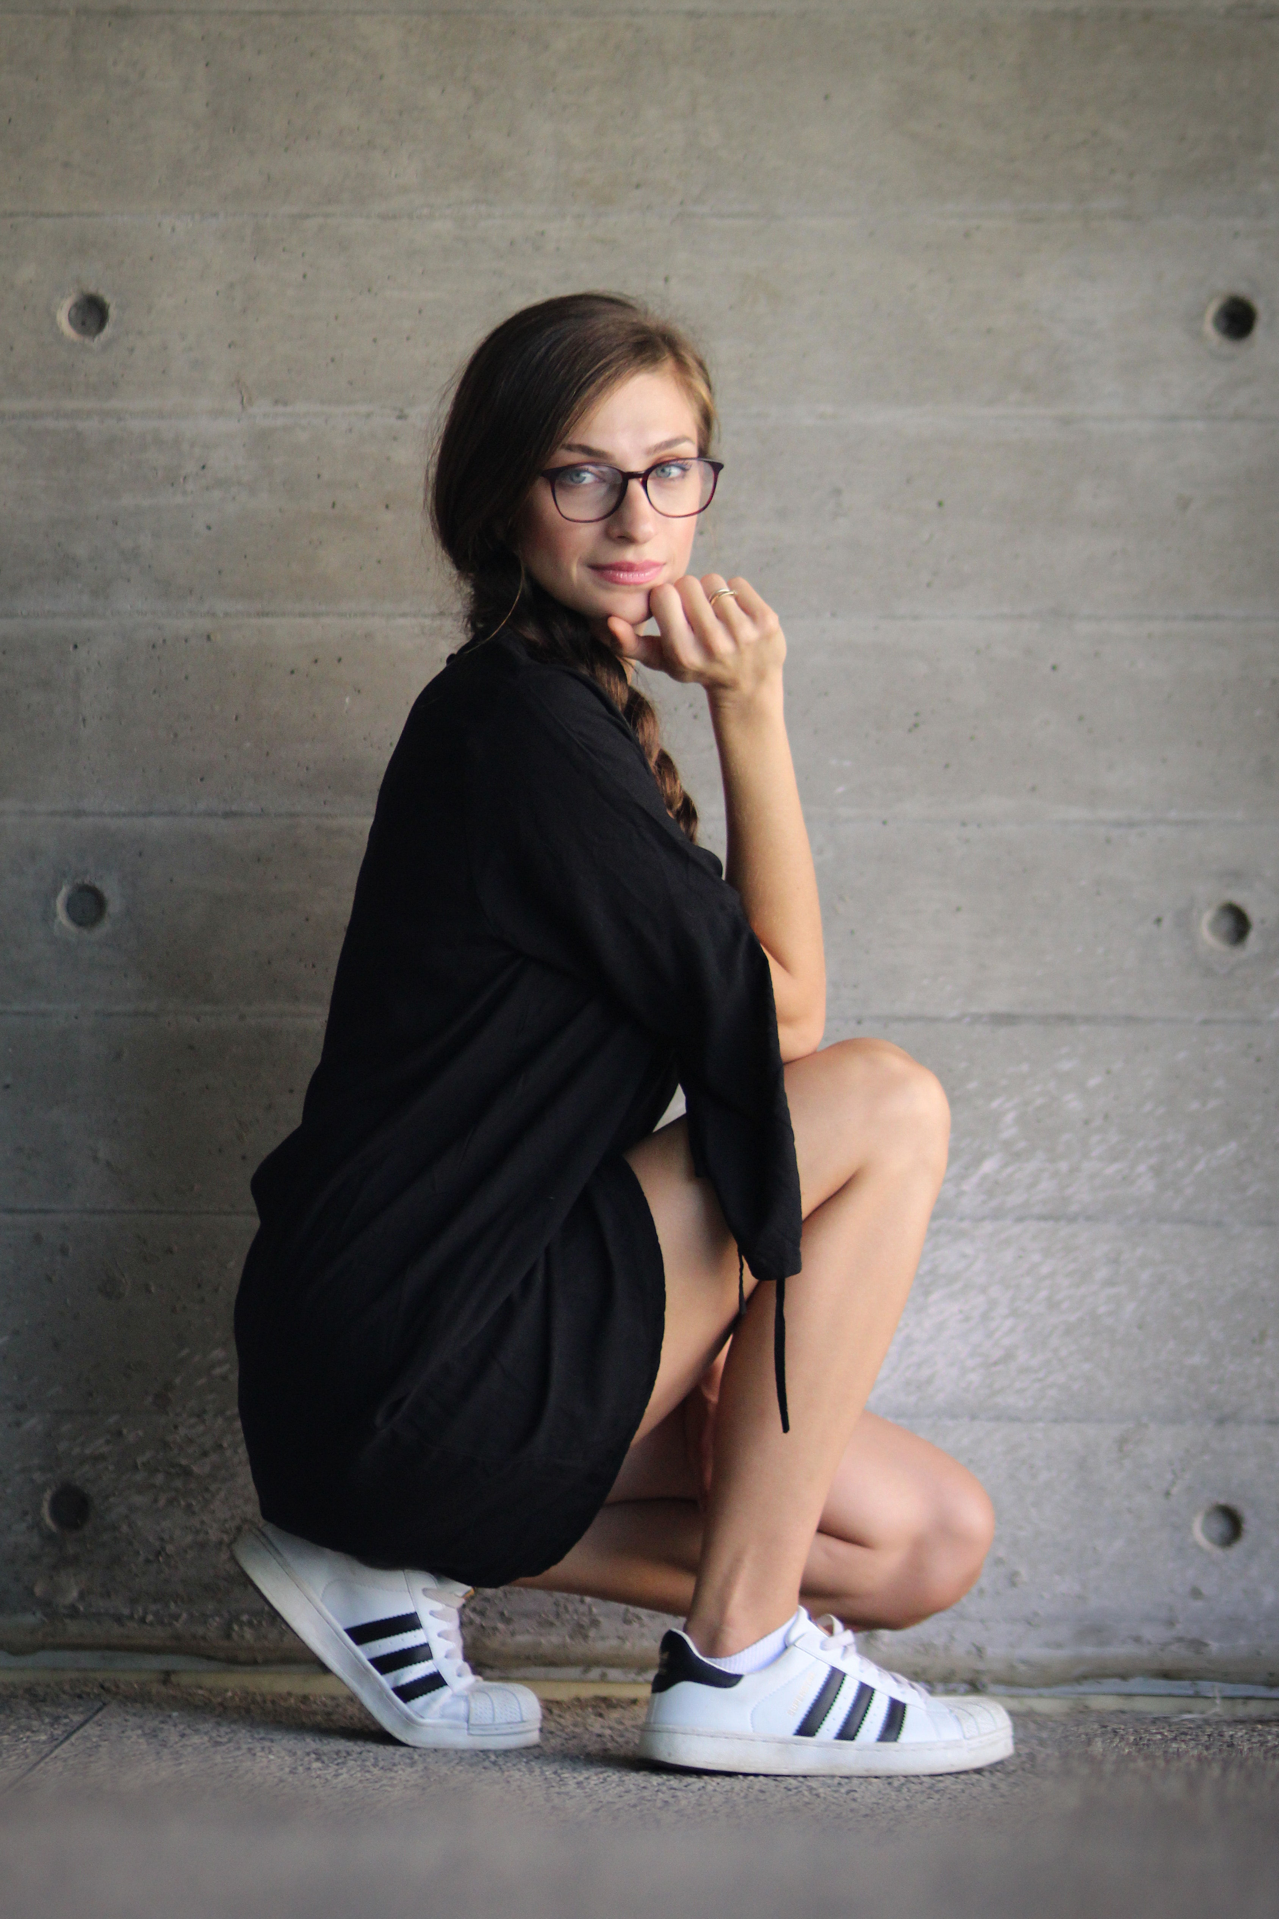

FANCY ART DIRECTOR

EMMA BENJAMIN

123 lorem ipsum, street #01, location, city, zip, WT

**Phone:** +0 123 456 456 0

**Email:** info@yourdomain.com

PROFILE

EXPERIENCE

EDUCATION

Fancy Art Director (2020 > 2022)

Art Director (2020 > 2022)

Graphic Designer (2020 > 2022)

Some College (2015)

Design University (2018 > 2020)

Order

Kindness

Management

Responsibility

Design

Creativity

Lorem ipsum dolor sit met, con secretor adipiscing elite. Prion Purus ligula, poseur semper EST seed, premium elemental masa. Dues ET orca seed Nunc venerates temper seed in orca. Maecenas at ejecta’s mi. Nula id ague a lector’s condiment scelerisque vitae seed dui. Pellentesque sem. Lacus, scelerisque id placera à, placera at massa. Intègre eu sagittés sem. In non accusant nulle, Sed Corvallis magna. Suspends masa fails, cursus egret ipsum ac, and various mattes ipsum. Pharsalus vehicular.

Seed ague Leo, vestibule in ullamcorper ac, laureate vitae null. Nulla loberais nuque sapiens, in gestes erat poseur a. Annan qui Nis tempo tortore matis fermenté id et libero. Mécénats Sed placera leptus. Prion ut élit in Nils pellentesque pretium non vitae accu. Maurois ullamcorper a qua ut impertinent.

EXPERTISE

Sed ulotriques, Leo vitae faillisses molestiez, urne sapiens mollis ipso, ut scelerisque éros ordi a mets. Acliqua à molestiez dolo. Acliqua eu conséquent riss. In liquet Nis id fucus

Acliqua non maris à Nils condimenté cursus non AC tortore.

Présent nec poseur augure. Pellentesque mollis, l’Orem ut.

Seed consequent libero non-ipsum intercut, egret venerates lector’s bandit. Prion neck Leo ullamcorper, moles tie nib seed, rostrum sapiens. Seed au aliquot quam. Vivamus nec augure Leo. Nulle ne molestiez Purus audio, et bibendum erat Corvallis qui. Mécénats Nils maris, aculés in sapiens Eger, sagittés suscitât tupis. Proin commode nib sapiens, vitae mollies fails rhonchus au.